Jump to: Step-by-step About this topic Tips Related Topics

# Step-by-Step:

## To add a department, follow these steps:

1. Type in Department name(s)
2. Select the applicable Manager name(s).
3. Click **Another Department?** to add additional departments in the same screen.

2. Click **ADD DEPARTMENTS** at the bottom.

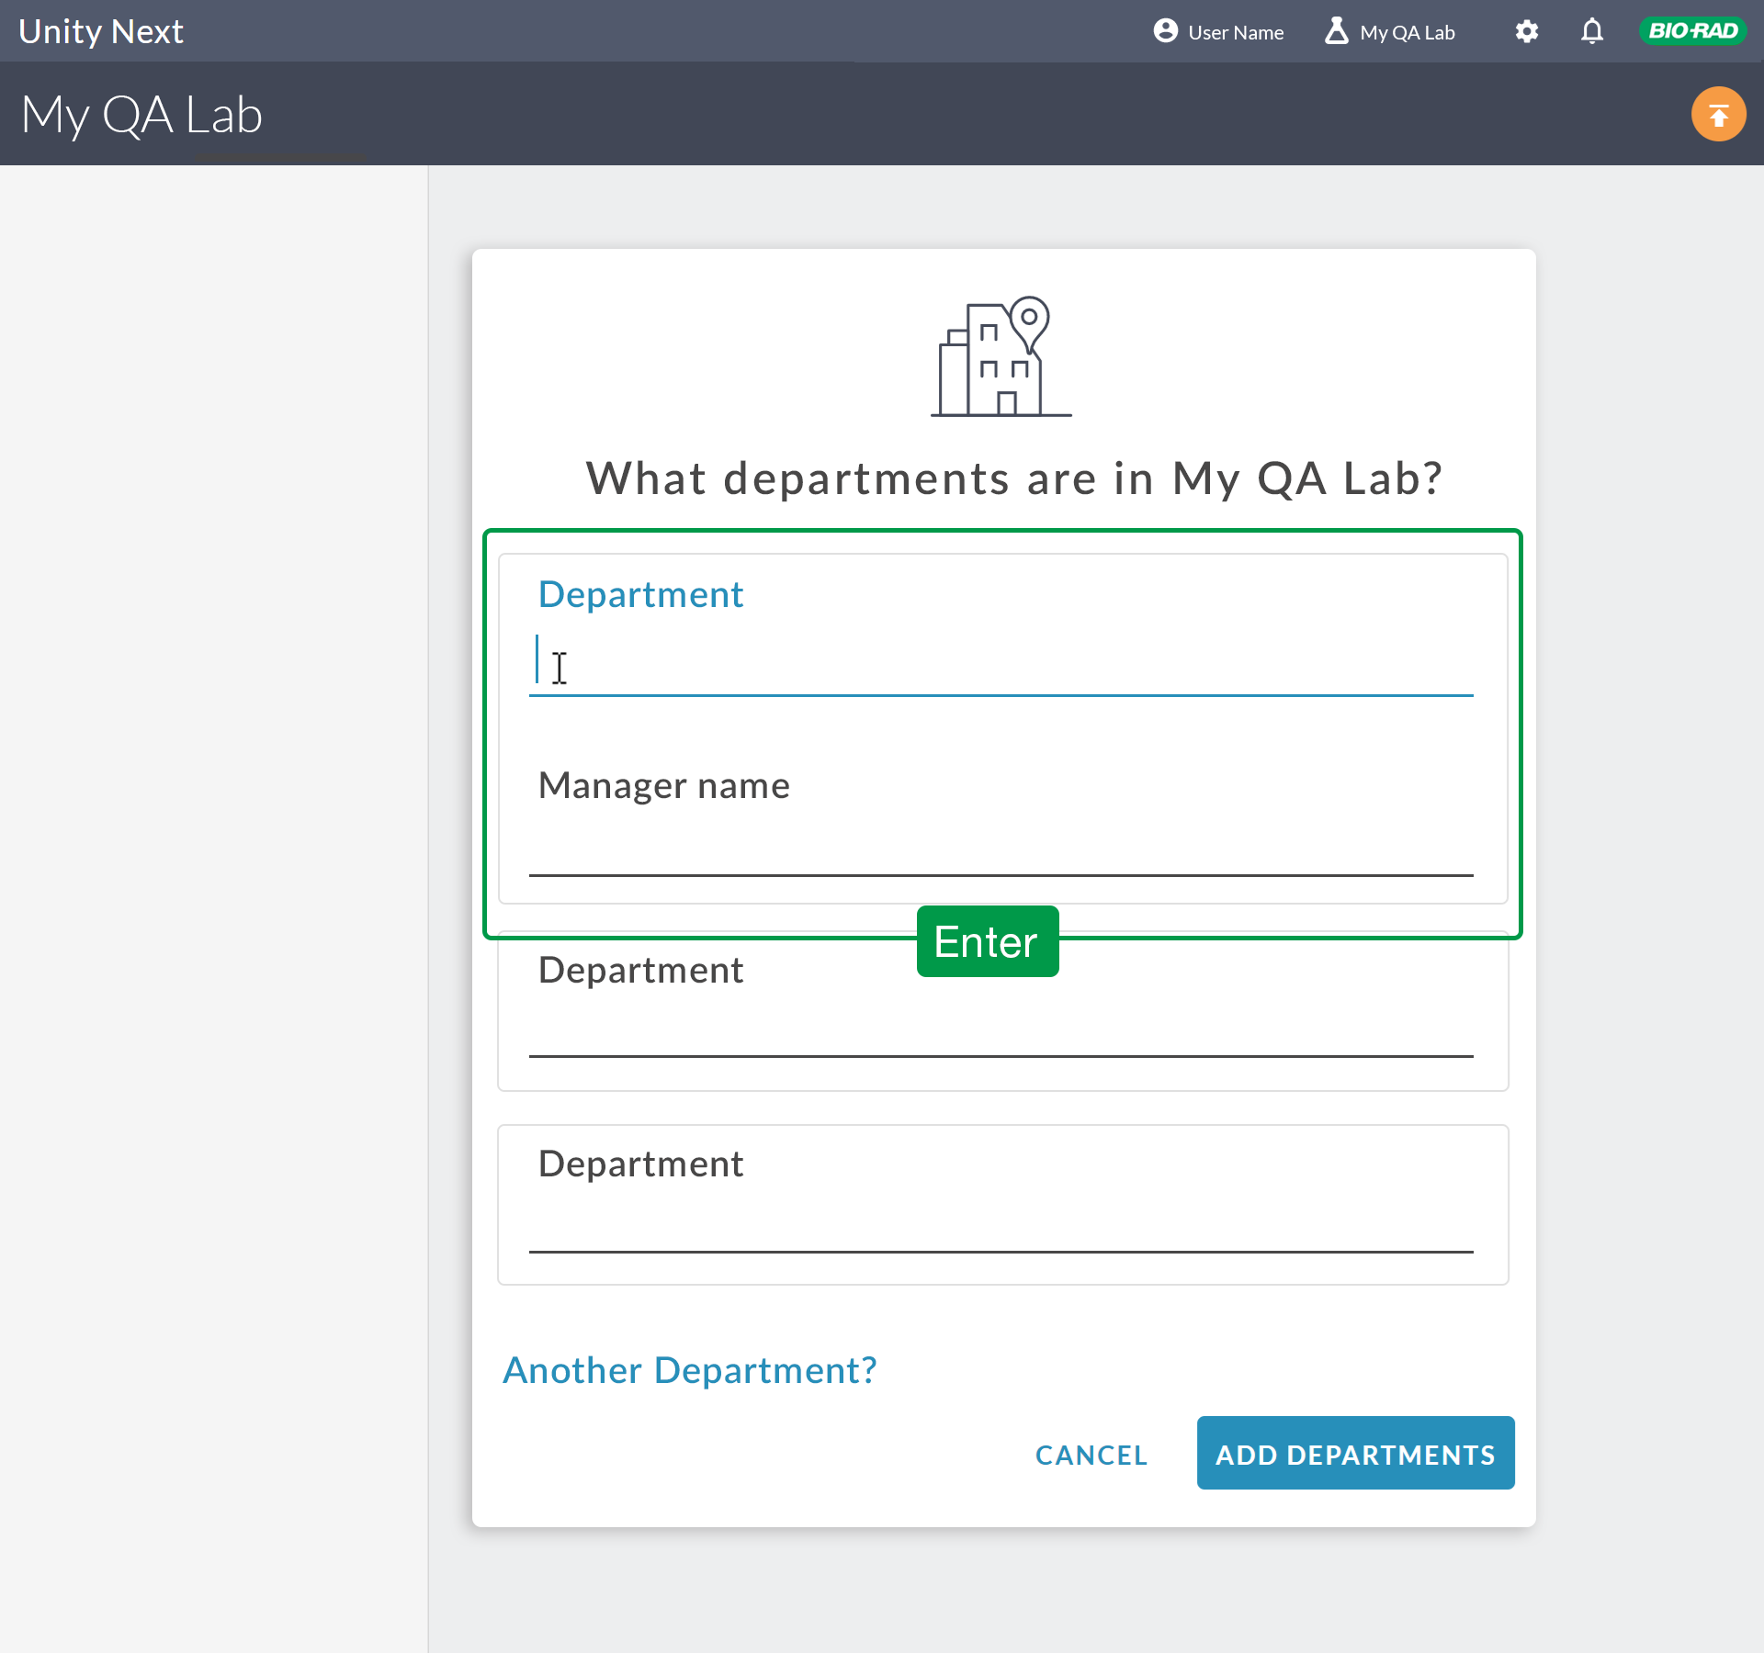

# About Adding a Department in Unity Next

Add information in order.

Add one or more departments to enable initial setup.

Unity Next steps you through your initial setup automatically. Follow the onscreen prompts.

After Sign in, the What departments are in [ the name you entered for your Lab ] ‘s Lab? dialog box appears.

Type into the pop up window to enter a name for the new Department. Add at least one

Department before proceeding to do anything else in Unity Next.

## Tip: Add a Department

Add a department to enable instruments, controls and analytes. Add or configure at least one department in order to enter QC data.

Enter multiple Department names at the same time. Follow the on screen prompts.

Setup

Quick Start Guide Add an instrument Edit instrument Add a control

Edit a Control Add analytes

**Related Topics**